HTM4PICS – A GUIDE

An application for easily generating HTML files to visualize cascading directories of images and videos

Joel Ivey
jivey@jiveysoft.com

A number of years ago, back in 2001, I created a small Perl script to generate html in a fairly reasonable manner so that I could give copies of pictures I had taken to family and friends in a structured manner, and so that they could view them without too much hassle. I then took advantage of ActiveState’s Perl developer kit and the functionality that it contained to convert my Perl script to a completely independent exe program that would run under Windows. This made it so that family and friends didn’t need to have Perl installed or know how to run Perl scripts. I still use this and other ActiveState tools to assist in my development. Across time, the program has been modified as picture sizes became enormous and different video and picture formats/extensions appeared.

Until now, however, I hadn’t provided the basic Perl script and instructions on how to use it on Linux to the general public. That is the aim of this document.

I am providing a zip file which contains all of the components, including both exe and pl versions of htm4pics. The user needs to open this zip file and get the components on to their system.

I moved the files included in the zip file on to the system and placed them in an htm4pics directory under my home directory. I then used dos2unix on the htm4pics.pl file just to be sure. I have accented with both size and color my input to the prompts. And some comments are added following <- - marks.

[jivey@jiveysoft ~]$ cd htm4pics
[jivey@jiveysoft htm4pics]$ ls <- - the basic contents of the zip file
audio3.gif autorun.inf htm4pics.pl movie3.gif ShowPics.exe
[jivey@jiveysoft htm4pics]$ dos2unix htm4pics.pl
dos2unix: converting file htm4pics.pl to Unix format ...

For the images, I created a directory ‘topdir’, again under my home directory, and then two directories under it Pics1 and Pics2 into which I placed a few image files. I did not have or make at the time thumbnails, which I do recommend, especially if there are a lot of images. On Windows systems, I have use Easy Thumbnails (ezthumbs.exe) a free download from Fookes software (www.fookes.com). I generally use 640 x 640 maximum image size and shrink only for thumbnails and prefix them with ‘tn_’ to identify them as thumbnails.
Move to the directory where htm4pics.pl (or htm4pics.exe on a windows system) and related files were placed (in my case ~/htm4pics on Linux – I would use C:\htm4pics on Windows), since some of the files included with it are copied into the directory that is chosen for processing. To run the script enter perl htm4pics.pl on Linux and simply htm4pics on Windows, and at the prompts enter the top directory to be processed, whether or not you need to make thumbnails (if you respond yes, it will stop processing), and a main title, then indicate whether what you meant was what you entered. It will then do the processing as shown here.
[jivey@jiveysoft htm4pics]$ perl htm4pics.pl
htm4pics version 1.24 (c) 2001-2014, joel ivey (jivey@jiveysoft.com)

Directory to process: ../topdir
Do you need to make thumbnails for images (Y/N)?N

What do you want the main title to be? Test On Linux
The main title will be:
Test On Linux
Correct (Y/N)? y
---analyzing 0---
---analyzing 1---
---analyzing 2---
---writing---
Processed 3 directories

Enter RETURN to exit: <- - and that completes the htm4pics processing
[jivey@jiveysoft htm4pics]$ cd ../topdir
[jivey@jiveysoft topdir]$ ls < - - topdir had only two directories in it Pics1, Pics2
autorun.inf htm4pics main.html Pics1 Pics2 ShowPics.exe
[jivey@jiveysoft topdir]$ ls Pics1 <- - nothing is added or changed in descendent directories
IMG_0621.JPG IMG_0622.JPG IMG_0623.JPG IMG_0624.JPG
[jivey@jiveysoft topdir]$ ls Pics2
IMG_8054.JPG IMG_8057.JPG IMG_8058.JPG IMG_8061.JPG
[jivey@jiveysoft topdir]$ ls htm4pics <- - This is a new directory
Pics1.html Pics2.html <- - and contains html files for directories under topdir
[jivey@jiveysoft topdir]$

The use of the main.html file generated by htm4pics on a Linux system is shown in the following images (and the instructions are the same for Windows systems), based on specifying that the images in and in subdirectories below the topdir directory were to be processed. The Firefox browser was opened and a Control-O keyboard entry made to select a file to open. The main.html file in the originally specified directory is selected.

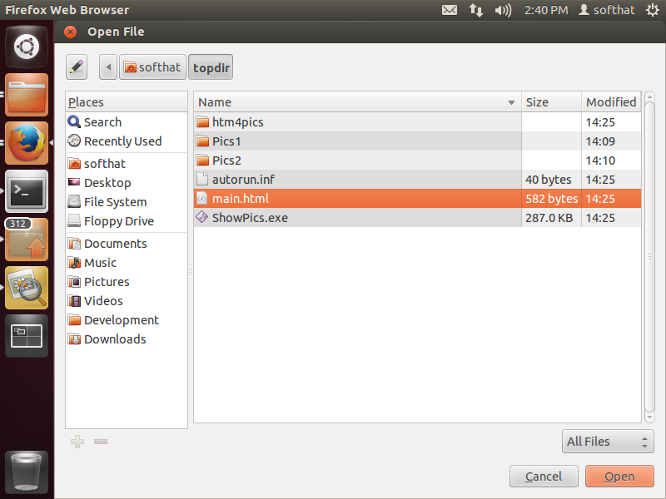
A file main.html is created in the top directory that was specified by the user (along with additional files and the htm4pics directory, which holds the rest of the html files). The autorun.inf and ShowPics.exe are included so that if these files are placed at the top of a CD or DVD created to hold them, autorun will, if permitted on a Windows system, start the ShowPics.exe, which I also wrote and which simply opens the main.html file, to run automatically. Here the main.html file is selected, and the Open button pressed to launch the content.
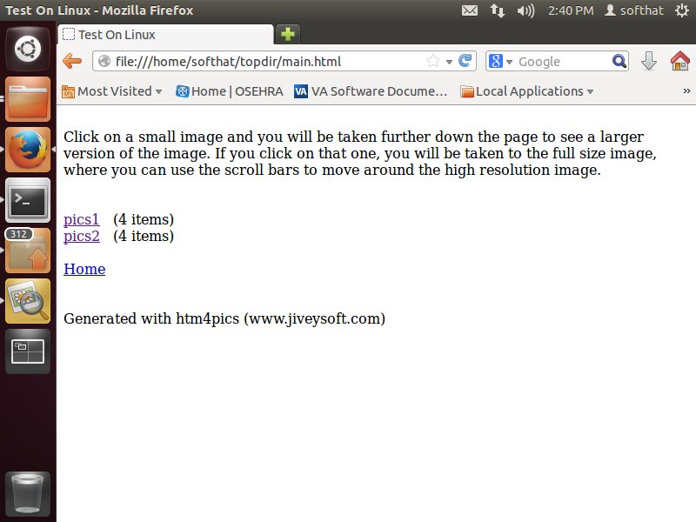
This image shows the opened html file, and a description of how the images may be displayed. The contents of the directories below the top one are reached by clicking the links shown with their names. If there are more than 30 images and/or videos in a directory, subsequent directories will be listed under the initial ones as a continuation.
If there are images in the top directory selected for inclusion, the one in which the main.html file is generated, they would be shown below the text. There should not be more than 30 images in the top directory, since that is the limit (due to the stress large files were putting on system resources) that the program will put into a single page.

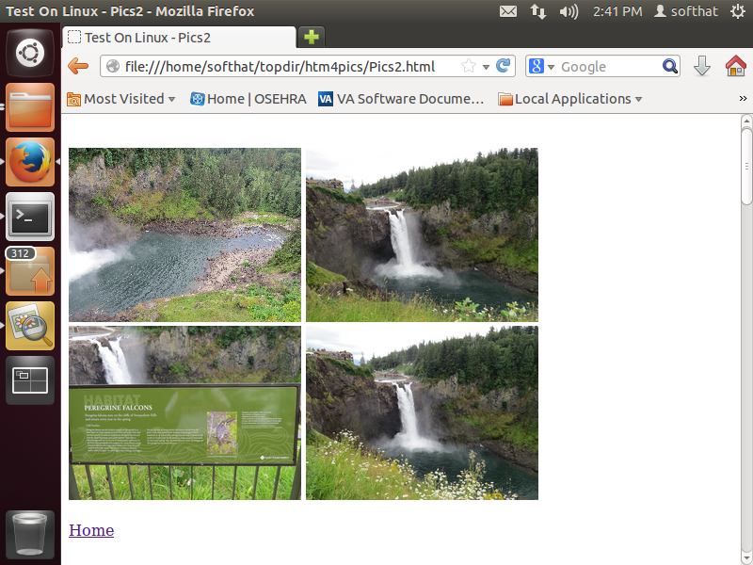
The opened page shows the images in a small format, and after the small format pictures there are links to the originally opened page (Home), or possibly links to the next images in the set if there were more than 30 images for the selected directory. These images are of Snoqualmie Falls, outside of Seattle, Washington.

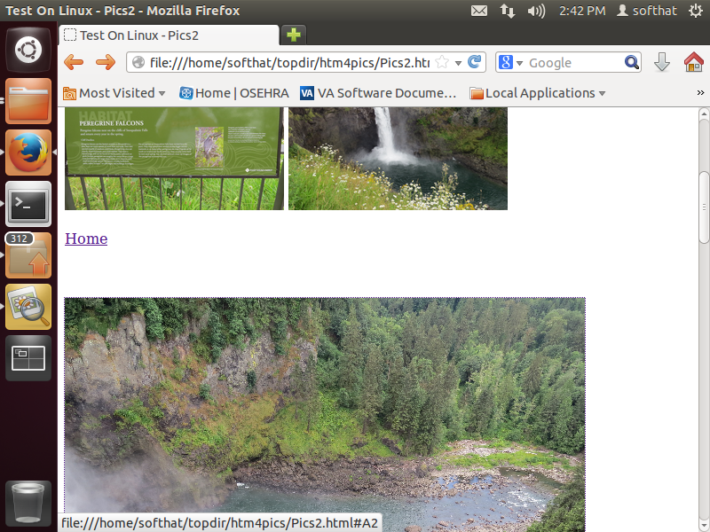
Scrolling down the page will take the user down to larger versions of the images or clicking on one of the small images above will take the user to the larger version of that image. Shown are the last two of the small images and the top part of the larger version of the first image.
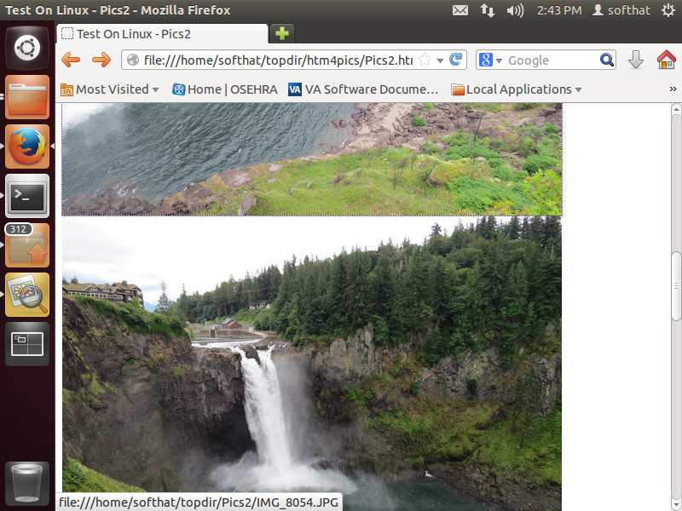
This shows the bottom of the first image and the top of the next (second) image in the larger format as we scrolled further down the page. Note that there is a building just above the top of the falls.
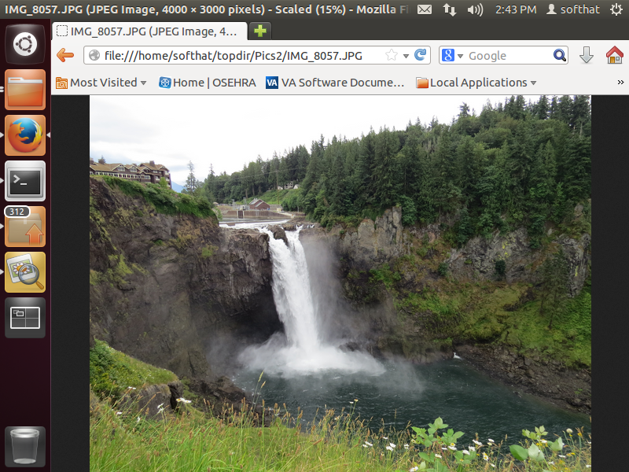
By clicking on a selected larger format image, the image will be opened in an even larger format (not shown here is ‘+’ icon showing the mouse location, so that on clicking on this image, it is expanded to its full size (which may be very large these days).
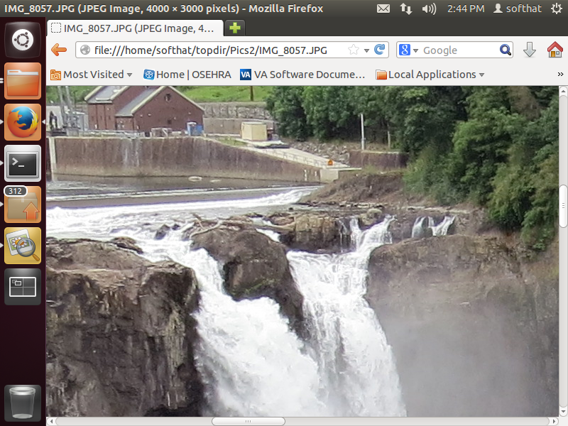
This shows the a part of the image after the mouse with the ‘+’ icon was clicked (the mouse icon then becomes a ‘-‘ which will reduce it back to an image that fits within the size of the window). And, now the building above the falls can be seen in much more detail. The default action of clicking the larger image in the original display opens the image in that window and the user then has to select the back arrow to return to the previous screen. To open it in a new tab or in a new window right click on the larger image on the original screen and select a new tab or new window.
And that is basically it with respect to the use of htm4pics to generate an html format for visualizing pictures and videos in a structured manner within web browsers, and viewing the resulting pages within the browser.

